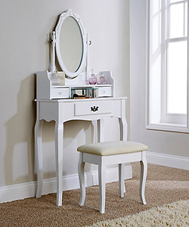

Dressing Table

$125.19

Availability: In stock

Description

The Spacious Tabletop offer you to display or store your stuff. Mirror assembled with two wood poles. The white color better highlight you in the mirror and make you focus on yourself. The whole design is elegant and clean.